**[Bridge edge in a graph](https://practice.geeksforgeeks.org/problems/bridge-edge-in-graph/1)**

Given a Graph of V vertices and E edges and another edge(c - d), the task is to find if the given edge is a Bridge**.** i.e., removing the edge disconnects the graph.

**Example 1:**

**Input:**

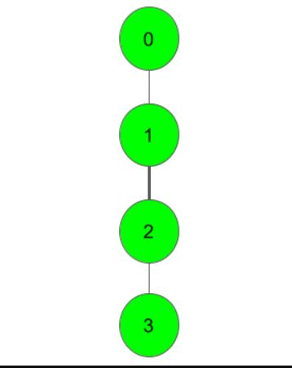

**c** = 1, **d** = 2

**Output:**

1

**Explanation**:

From the graph, we can clearly see that

blocking the edge 1-2 will result in

disconnection of the graph. So, it is

a Bridgeand thus the Output 1.

**Example 2:**

**Input:**

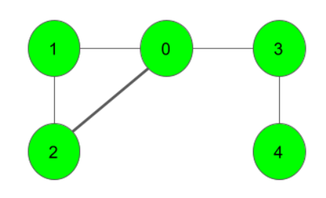

**c** = 0, **d** = 2

**Output:**

0

**Explanation**:

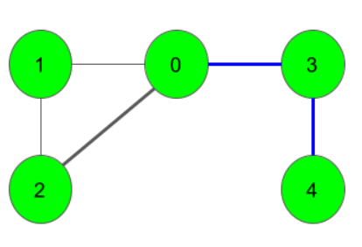

blocking the edge between nodes 0 and 2

won't affect the connectivity of the graph.

So, it's not a Bridge Edge. All the Bridge

Edges in the graph are marked with a blue

line in the above image.

**Your Task:**  
You don't need to read input or print anything. Your task is to complete the function **isBridge()**  which takes number of vertices V**,**the number of edges E**,**an adjacency lsit adj and two integers c and d denoting the edge as input parameters and returns 1 if the given edge c-d is a Bridge**.** Else, it returns 0.

**Expected Time Complexity:** O(V + E).  
**Expected Auxiliary Space:** O(V).

**Constraints:**  
1 ≤ V,E ≤ 105  
0 ≤ c, d ≤ V-1